EduAIThon Report

Title : Propulsion System
Faculty Mentor : Mr. B. Manideep, Assistant Professor MLRIT.
Authors : K. Shrilekha - 3rd Yr - CSD
M. Madhucharan - 3rd Yr - IT
G. Kishan - 2nd Yr - AERO
Institution : MLR Institute of Technology
Keywords : Propulsion system, thrust generation, 3D engine simulation, physics-based modeling, airflow dynamics, combustion process, real-time visualization, engineering education, Three.js, aerospace propulsion, AI-assisted learning.

ABSTRACT :

Understanding propulsion systems remains challenging for beginners due to the heavy emphasis on mathematical formulations, theoretical instruction, and static representations in traditional learning methods. These approaches often fail to provide intuitive insight into internal engine processes, resulting in reduced conceptual clarity and learner engagement. This work presents PropulseAI, an AI-driven interactive learning platform designed to improve conceptual understanding of propulsion systems through visualization and guided experimentation. The proposed system integrates simplified propulsion simulations with real-time 3D visualizations to represent internal phenomena such as airflow behavior, thermal variation, and thrust generation. An adaptive AI guidance model functions as a virtual instructor by analyzing user interactions, providing contextual explanations, identifying design errors, and offering corrective feedback in an accessible manner. The learning framework emphasizes interaction and visual reasoning rather than equation-centric instruction. System validation is performed through structured user interaction scenarios and feedback-based evaluation, demonstrating improved intuition, engagement, and confidence among beginner users when compared to conventional teaching approaches. PropulseAI offers an effective and scalable solution for introductory propulsion education, bridging the gap between theoretical knowledge and intuitive understanding for both engineering and non-engineering learners.

- INTRODUCTION:

Propulsion systems play a critical role in aerospace and transportation technologies by enabling the generation of thrust required for motion in aircraft, rockets, and other vehicles. Despite their importance, propulsion is often considered difficult to understand by beginners due to the strong dependence on mathematical formulations, complex theory, and static diagrams in traditional teaching methods. Learners are frequently required to imagine internal engine processes such as airflow movement, heat generation, and thrust production without adequate visual support, which limits intuitive understanding. This gap between theoretical instruction and conceptual clarity often results in memorization-based learning, reduced engagement, and lack of confidence among students. The motivation for this work arises from the need to make propulsion education more accessible and intuitive, especially for learners with little or no prior engineering background.

Objectives:
- To simplify propulsion system learning for beginners.
- To provide visual and interactive understanding of engine behavior.
- To use AI guidance for clear and personalized explanations.
- To build learner confidence through safe experimentation.

- RELATED WORK :

Existing tools:
- Textbooks and Lectures – Focus on theory and equations
- Static Diagrams – Show engine structure without interaction
- Engineering Simulation Software – Accurate but complex and expert-oriented
- Educational Videos and Animations – Visual but non-interactive
- Virtual Labs – Limited interaction and feedback

Most existing tools emphasize theoretical knowledge or numerical analysis, making them unsuitable for beginners. Internal engine behavior remains difficult to visualize, and learners are often unable to understand cause-and-effect relationships. Advanced simulation tools require prior expertise, while simpler resources lack interactivity and personalized guidance. Additionally, most systems do not support safe experimentation or explain mistakes, leading to memorization rather than conceptual understanding.

Comparison:

Aspect | Traditional Methods | Simulation Software | PropulseAI (Proposed)
Learning Approach | Theory and formula-based | Analysis-focused | Conceptual and interactive
Visualization | Static diagrams | Complex technical visuals | Simple real-time visuals
User Interaction | Minimal | High but complex | High and beginner-friendly
Guidance | Instructor-dependent | Limited or none | AI-based personalized guidance
Mistake Handling | Penalizing | Technical error outputs | Explained as learning moments
Target Users | Engineering students | Advanced users | Beginners and non-engineers
Learning Focus | Memorization | Numerical accuracy | Intuition and understanding

- PROBLEM STATEMENT & LEARNING OBJECTIVE:

Problem Statement:
Understanding propulsion systems is difficult for beginners due to heavy reliance on mathematical theory and static diagrams, which makes it hard to visualize internal engine processes such as airflow, heat generation, and thrust production. This often leads to memorization instead of true conceptual understanding, causing confusion and low engagement. To bridge this gap, there is a need for an interactive, visualization-driven, and learner-centered approach that promotes intuitive learning and deeper understanding.

Learning Objective:
- Enable learners to visualize internal propulsion processes clearly.
- Promote conceptual understanding instead of memorization.
- Develop Higher Order Thinking Skills (HOTS) through analysis, prediction, and evaluation.
- Encourage self-directed learning based on heutagogy principles.
- Allow learners to experiment and explore at their own pace.
- Provide AI-based guidance with real-time feedback and explanations.
- Improve learner confidence, engagement, and problem-solving ability.

- SYSTEM ARCHITECTURE :
The propulsion system application is designed with a modular architecture that supports secure user access, structured learning, progress monitoring, and interactive experimentation. The system begins with a user authentication module that validates credentials and initiates a secure session.
After successful login, users are directed to the main application interface, where they can choose between the Learning Phase and the Experimental Phase. The Student Dashboard is accessible within the system and allows users to view their learning progress, completed modules, and experimental activity status. The dashboard functions as a progress-monitoring and reference module rather than the initial landing page.
The application consists of two core phases: the Learning Phase and the Experimental Phase. The learning phase provides theoretical knowledge of propulsion systems through structured content and visual explanations of engine components and working principles. User progress is continuously tracked.
The experimental phase enables users to interact with a real-time 3D propulsion engine simulation. Users can adjust engine parameters, and a physics-based simulation engine dynamically updates the 3D model to visualize airflow, temperature variation, and thrust generation.
A session management layer maintains system continuity and data integrity across all modules. The system concludes with a secure logout process that saves user progress and terminates the session.
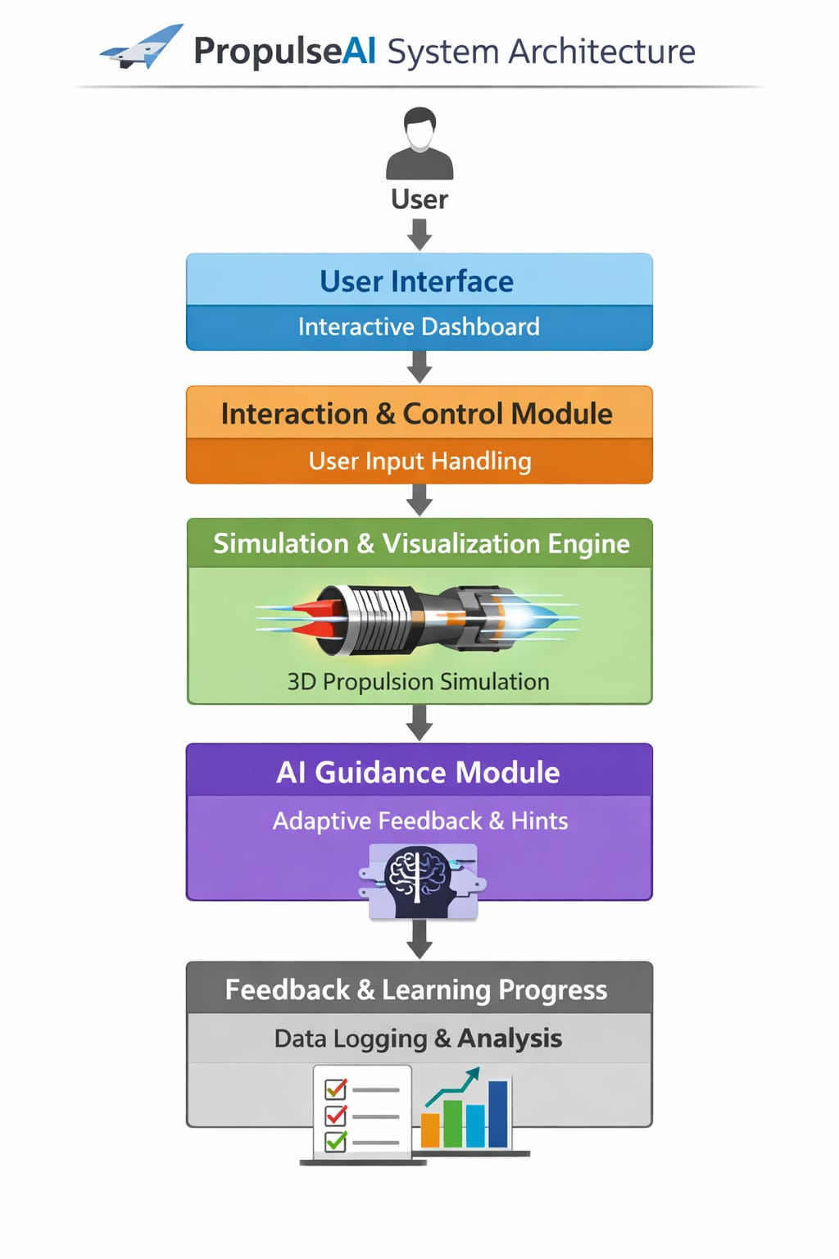
- EDUCATIONAL MODEL DESIGN :
The educational model of the proposed propulsion system is designed to support conceptual understanding, experiential learning, and self-directed exploration. The system adopts a blended pedagogical approach combining constructivism, experiential learning, and heutagogy.
The learning process begins with a structured Learning Phase, where core propulsion concepts such as engine components, airflow dynamics, combustion, and thrust generation are introduced using visual and interactive content. This phase builds foundational knowledge and prepares learners for practical application.
Learners then transition to the Experimental Phase, where they interact with a real-time propulsion engine simulation. By adjusting engine parameters and observing system responses, students learn through direct experience and exploration. This approach promotes Higher Order Thinking Skills (HOTS), including analysis and evaluation.
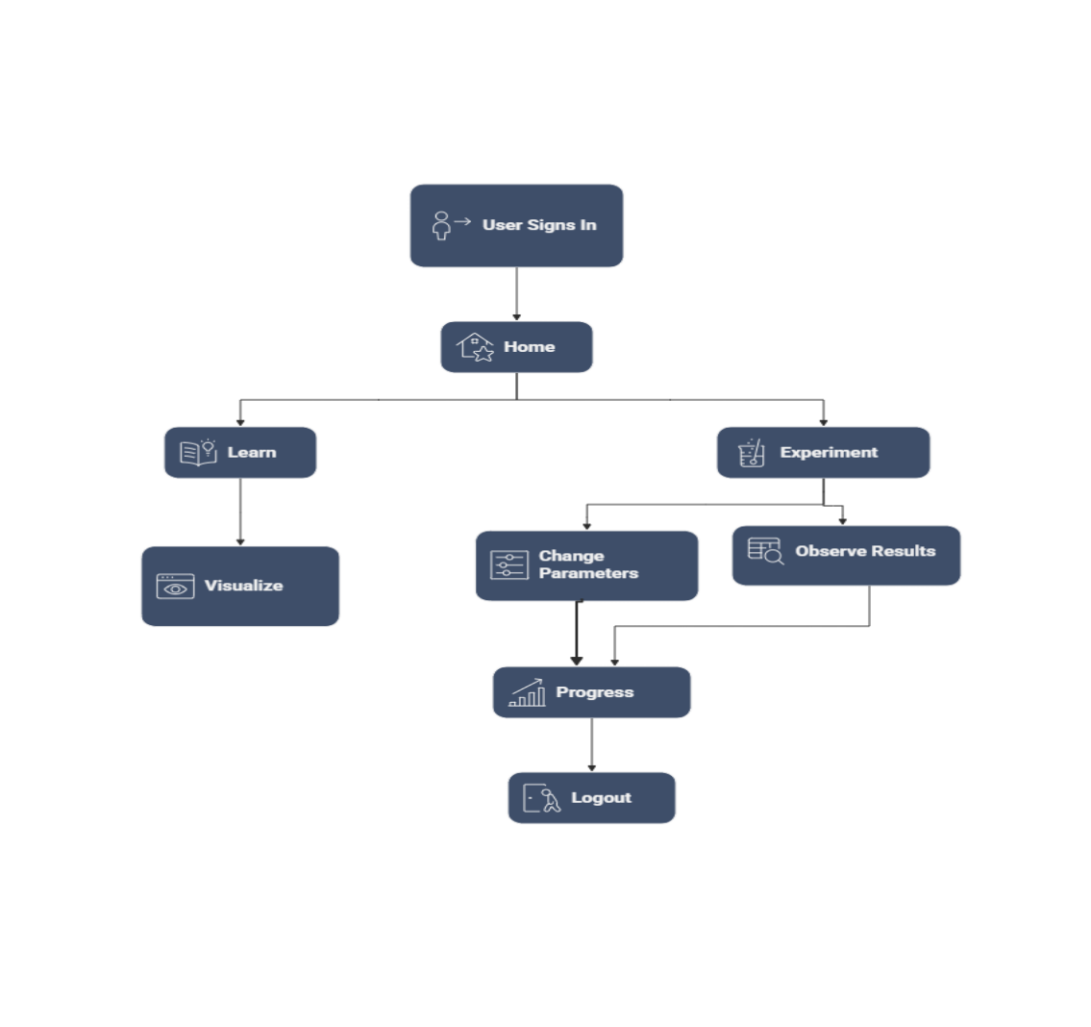
The learning flow follows a progression from theory to guided exploration and hands-on experimentation, allowing learners to connect theoretical principles with practical outcomes. Continuous progress tracking supports reflection, reinforces learning, and encourages self-paced advancement.
Overall, the educational model enhances engagement, conceptual clarity, and practical understanding of propulsion systems through an interactive and learner-centric approach.
- AI MODEL DEVELOPMENT :
The AI model in the proposed propulsion system is designed to support adaptive learning, performance analysis, and intelligent feedback rather than high-risk physical prediction. The model operates on user interaction data and simulation outputs to enhance the learning experience.

Dataset :

The dataset consists of user interaction logs, learning progress records, and simulation parameters such as throttle input, fuel flow variation, temperature change, and thrust output. Additional data includes time spent on modules, experimental attempts, and completion status. This data is collected in real time during system usage.

Model Design :
A hybrid AI approach is adopted, combining rule-based logic with lightweight machine learning techniques. The model analyzes patterns in user behavior and simulation results to identify learning progress, common misconceptions, and performance trends. The focus is on interpretability and responsiveness rather than computational complexity.

Training Process :
The model is trained using historical interaction data and predefined learning rules derived from propulsion theory. Supervised learning techniques are used where labeled outcomes (such as correct understanding or successful experimentation) are available. The training process ensures alignment between system feedback and educational objectives.

Model Tuning :
Model tuning is performed by adjusting thresholds, rules, and learning parameters based on validation results and user feedback. Continuous monitoring allows the system to refine recommendations and feedback accuracy over time, ensuring effective and personalized learning support.
- VISUALIZATION / AR / VR / SIMULATION :

Tools Used
- Three.js for real-time 3D rendering and visualization.
- WebGL for hardware-accelerated graphics.
- JavaScript for interaction handling and simulation control.
- Physics-based simulation logic for engine behavior modelling.
- Optional AR/VR frameworks for immersive visualization (future-ready).

The system uses real-time 3D visualization to represent propulsion engine components and dynamic processes such as airflow, combustion, and thrust generation. Users interact with the simulation through intuitive controls that modify engine parameters, with immediate visual feedback. The simulation is physics-based but optimized for real-time performance, making it suitable for educational use. The design also supports future AR and VR integration for immersive learning experiences.

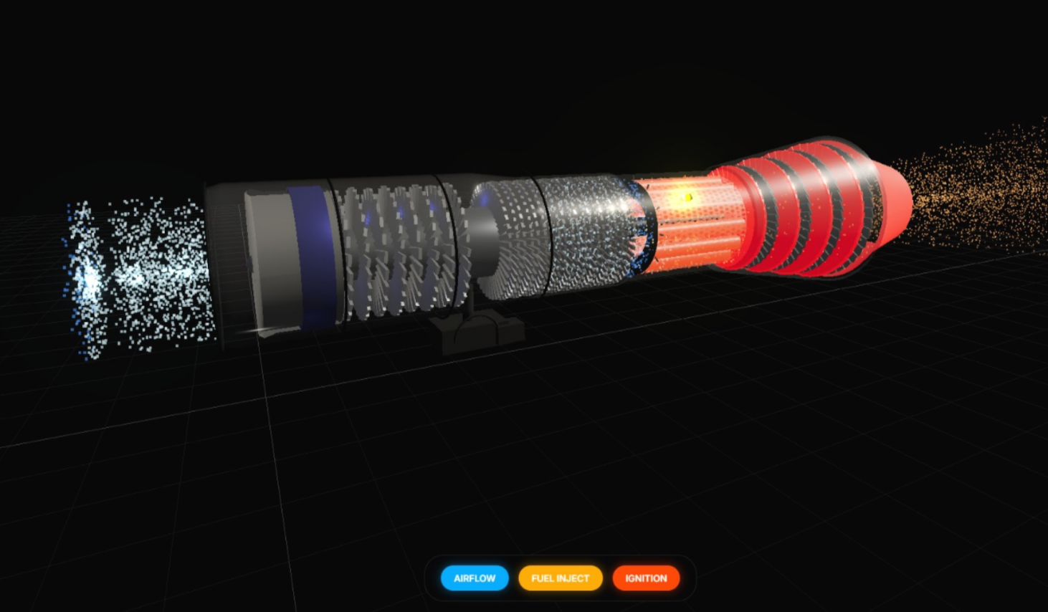

- IMPLEMENTATION DETAILS :
Technologies Used
- HTML, CSS, and JavaScript for front-end development.
- Three.js for 3D visualization and engine rendering.
- WebGL for graphics acceleration.
- Physics-based simulation logic for engine behavior.
- Backend services for user authentication and data storage.
The application is deployed as a web-based platform to ensure accessibility across devices without requiring specialized hardware. The system follows a modular architecture that enables easy updates and scalability. Backend services handle authentication, session management, and progress tracking, while the front end manages visualization and user interaction. The deployment approach supports smooth performance, secure access, and future integration of advanced features such as AI personalization and AR/VR modules.
- EVALUATION & VALIDATION :

Model Metrics :
The performance of the AI-assisted simulation model is evaluated using system-level and behavioral metrics rather than purely numerical prediction accuracy. Key evaluation metrics include simulation responsiveness, stability under varying input parameters, and consistency with fundamental propulsion principles. The AI model is assessed based on its ability to provide relevant feedback, correctly identify user interaction patterns, and adapt recommendations according to learner behavior. System latency and real-time rendering performance are also monitored to ensure smooth and reliable interaction.

Educational Validation :
Educational validation is conducted to assess the effectiveness of the system as a learning tool. Learner progress data, module completion rates, and experimental engagement levels are analyzed to evaluate knowledge acquisition. Pre- and post-learning comparisons are used to measure conceptual improvement. User feedback and observation of interaction behaviour are also considered to validate improvements in understanding, engagement, and higher-order thinking skills. The results indicate that the system effectively supports experiential learning and enhances conceptual clarity in propulsion system education.
- RESULTS AND DISCUSSION :
The results of the proposed propulsion system demonstrate the effectiveness of integrating interactive simulation and AI-assisted learning in engineering education. Users showed improved understanding of propulsion concepts, particularly in areas such as thrust generation, airflow dynamics, and engine operation, after engaging with both the learning and experimental phases.
The interactive 3D visualization enabled learners to clearly observe the relationship between input parameters and engine behavior, supporting experiential and inquiry-based learning. The experimental phase encouraged active exploration, leading to better analytical thinking and problem-solving skills. Progress tracking data indicated increased engagement and consistent completion of learning modules.
From a system perspective, the simulation performed reliably under varying input conditions, providing stable real-time feedback with minimal latency. The AI-driven feedback mechanisms contributed to personalized learning by identifying interaction patterns and guiding learners toward improved understanding.
Overall, the findings indicate that the system successfully bridges the gap between theoretical instruction and practical application, making propulsion system education more intuitive, engaging, and effective.
- INNOVATION & IMPACT :
The proposed propulsion system introduces an innovative approach by integrating interactive 3D visualization with physics-based simulation to enhance conceptual understanding of propulsion mechanisms. Unlike conventional static models, the system allows users to observe real-time changes in airflow, combustion behavior, and thrust generation based on user-controlled parameters. The combination of a learning-oriented framework with an experimental simulation environment represents a novel educational and analytical tool for propulsion system studies.
Impact
- Enhances understanding of propulsion system concepts through interactive 3D visualization.
- Provides a safe and cost-effective environment for experimenting with engine behavior.
- Bridges the gap between theoretical learning and practical application.
- Supports aerospace education, training, and skill development.
- Improves learner engagement through real-time feedback and simulations.

Scalability
- Modular architecture allows easy integration of new propulsion engine models.
- Can be extended to include advanced simulations and additional parameters.
- Supports deployment across multiple devices through a web-based platform.
- Adaptable for academic, research, and industrial training use cases.
- Future-ready design enables multi-user access and feature expansion.

- CONCLUSION AND FUTURE WORK :
PropulseAI is an AI-powered interactive platform that simplifies propulsion system learning for beginners by emphasizing visual, interactive, and experiential education over equation-heavy instruction. Through simplified simulations, real-time visualization, and AI-guided explanations, learners gain conceptual clarity, understand cause-and-effect relationships, and build confidence through safe experimentation. Evaluation shows improved understanding, engagement, and reduced reliance on memorization compared to traditional methods.
- Extend the platform to cover advanced propulsion concepts and higher-fidelity simulations.
- Integrate full AR/VR environments to enhance spatial understanding and immersive learning.
- Implement AI-based personalized learning paths and adaptive difficulty levels.
- Incorporate learning analytics to track progress and improve individual outcomes.
- Expand the framework to other engineering domains for broader applicability.

- REFERENCES :

- J. D. Anderson, Introduction to Flight, 8th ed., New York, NY, USA: McGraw-Hill Education, 2016.
- J. D. Mattingly, Elements of Propulsion: Gas Turbines and Rockets, Reston, VA, USA: American Institute of Aeronautics and Astronautics (AIAA), 2006.
- G. P. Sutton and O. Biblarz, Rocket Propulsion Elements, 9th ed., Hoboken, NJ, USA: John Wiley & Sons, 2017.
- H. Cohen, G. F. C. Rogers, and H. I. H. Saravanamuttoo, Gas Turbine Theory, 7th ed., Harlow, U.K.: Pearson Education, 2017.
- S. Farokhi, Aircraft Propulsion, 2nd ed., Hoboken, NJ, USA: John Wiley & Sons, 2014.

